Task 1: Provision the lab environment

Creating tree virtual networks and deploying tree virtual machines in them

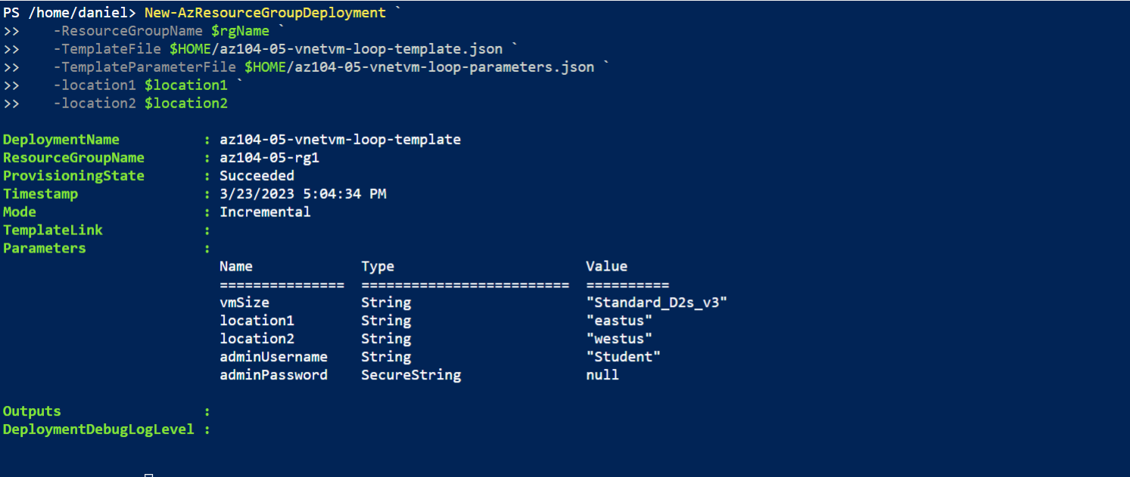

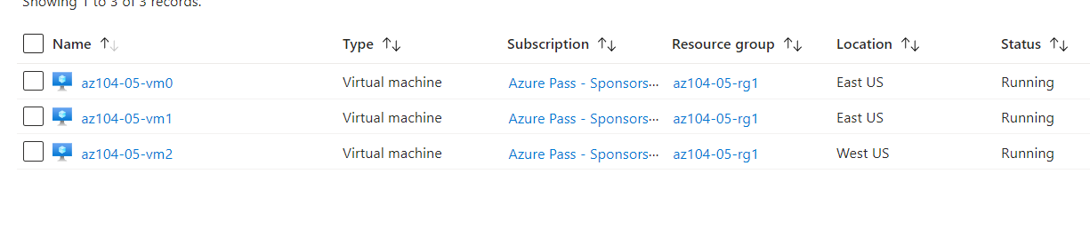

#### Task 2: Configure local and global virtual network peering

Added peerings to virtual network az104-05-vnet0

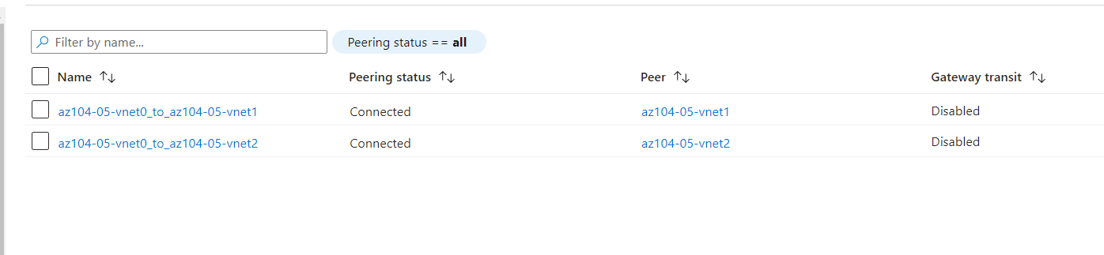

Added peerings to virtual network az104-05-vnet1

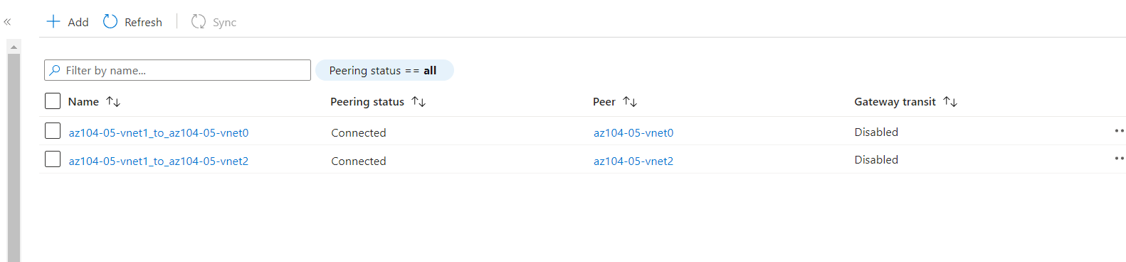

* Task 3: Test intersite connectivity

Testing connectivity to az104-05-vm1 and az104-05-vm2 from az104-05-vm0

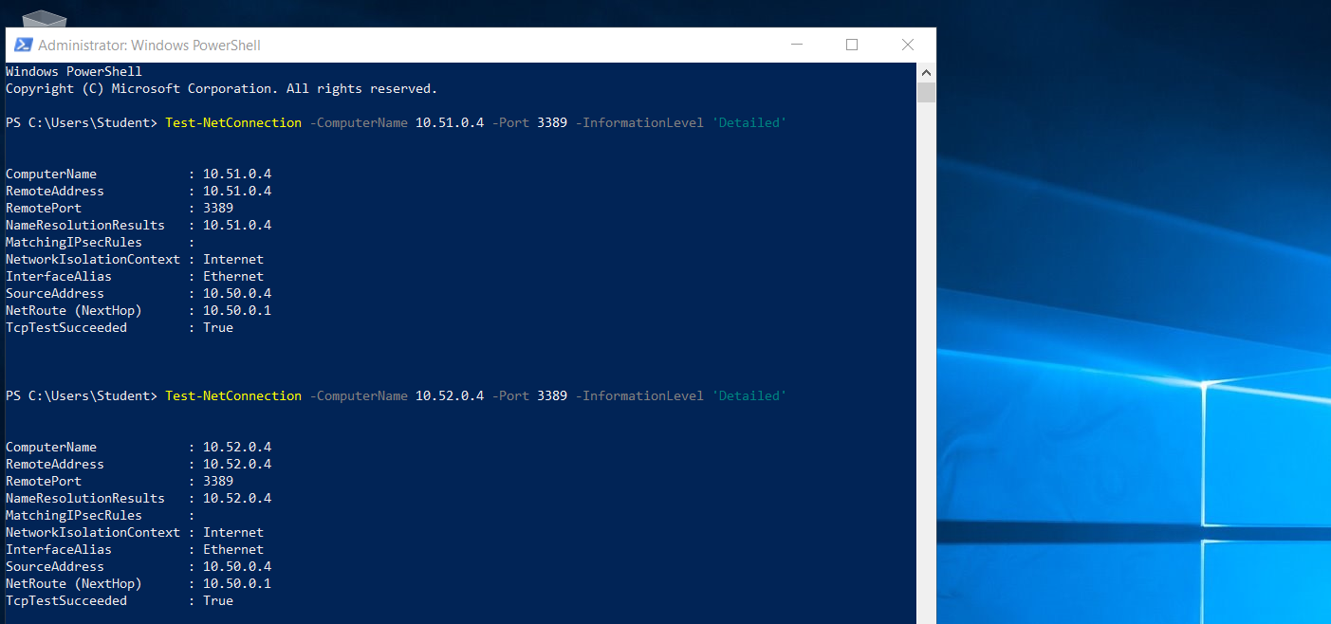

Testing connectivity to az104-05-vm2 from az104-05-vm1

